Amelia Steenmeyer

CIS241: Web Development

**Competency Demonstration Project**

Amelia Steenmeyer Portfolio WebSite

L. Ho

CIS241: Web Development

Date: 3rd, December 2018

Website: Loaded to GitHub______ (Pending Confirmation)

**Personal Home Page (home.html)**

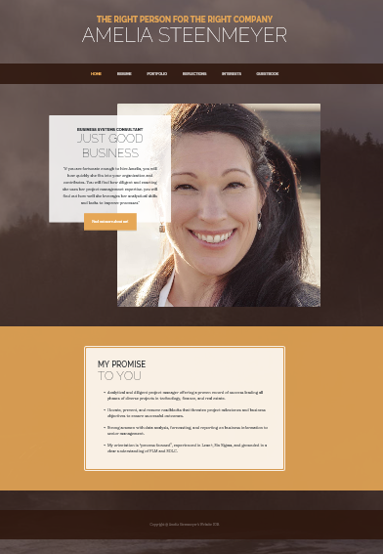

Template Help: Class Lessons (bullets; scroll freeze; centering; etc…; bootstrap.com; CodeHelp; & Various Blogs)

Background: Amelia Steenmeyer Personal Pictures from Heceta Head Lighthouse 2015

Verbiage Sources: Amelia Steenmeyer & Paul Victor (Sr. Manager Letter of Recommendation)

* Embedded graphics throughout this Web site.
* Three to four paragraphs about yourself and your interests. I kept it to 4 sentences and a quote. I added extra tabs at the top to put additional information about me.
* A resume - built in tables, saved as resume.htm (a later assignment/project). Please Navigate to resume via github

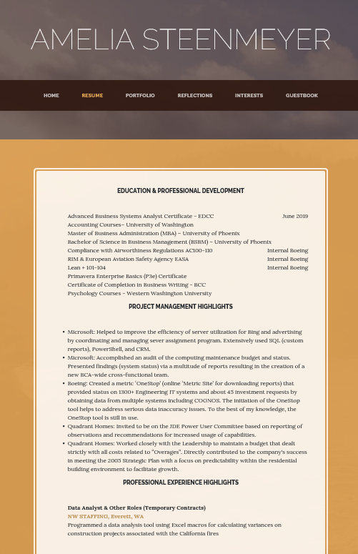

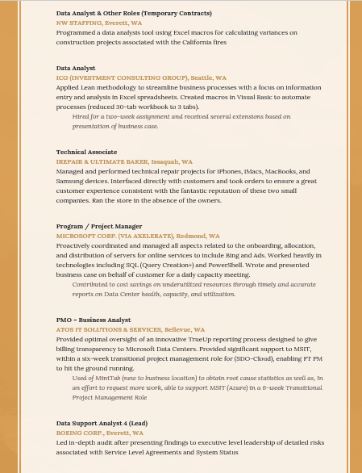

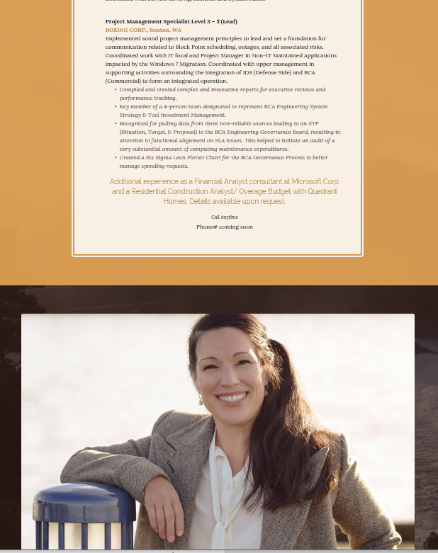

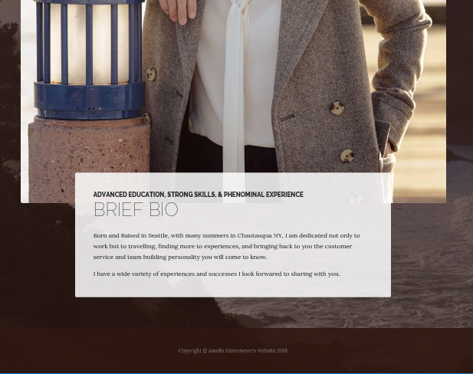

* A "mailto" guestbook form, saved as guestbook.htm how your visitor found you, as either a drop down list or radio buttons.  Options should be like
  + A text box for the visitor's Web site with a default value of http:// displayed.
  + A text area for your visitor to include comments.

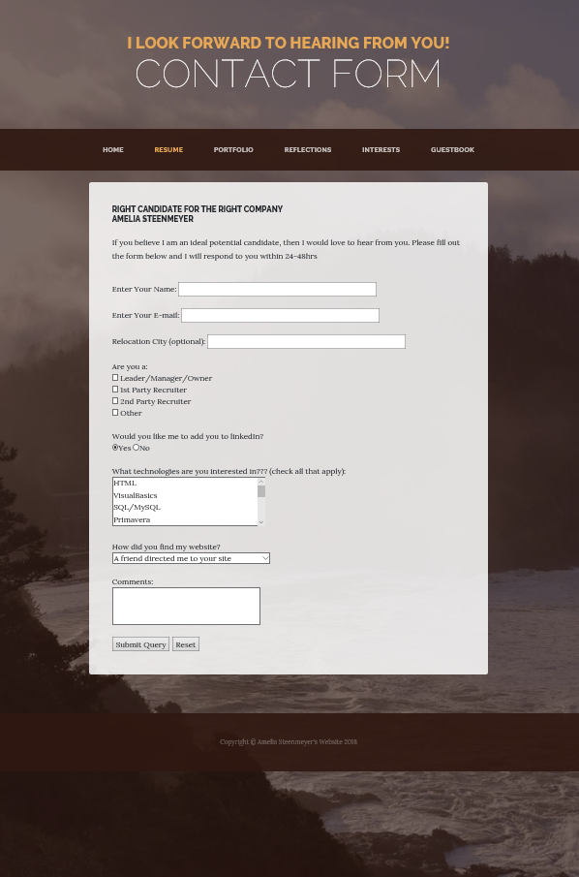

* An interest page saved as interest.htm. This page should include links to at least 4 other Web sites, you should present these links: as a list, using either an ordered or unordered list. should open in a new browser instance.

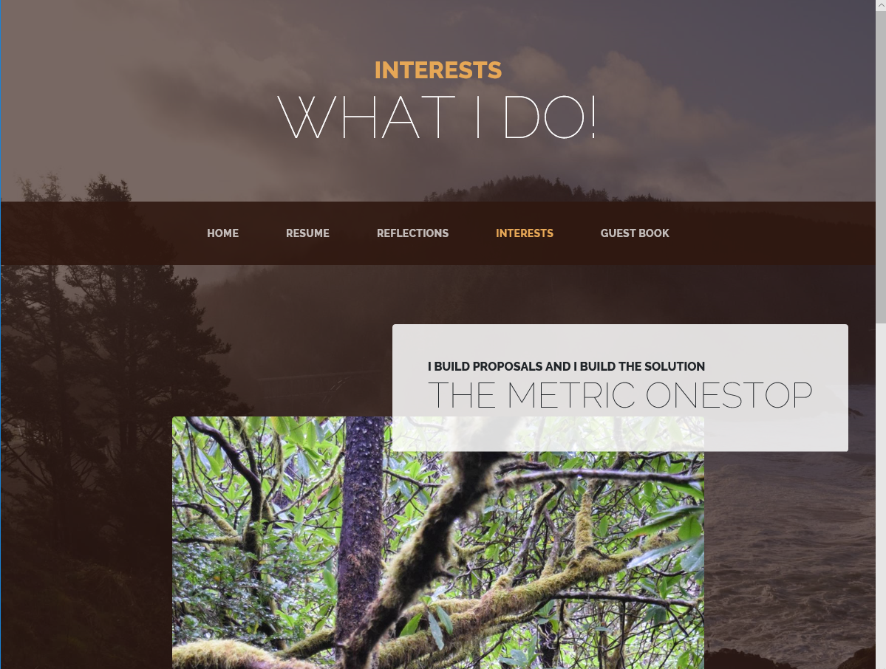

* A reflections page saved as reflections.htm.  This page will allow you to reflect on what you learned this quarter.  What "Ah ha!" moment did you have in the course.  I'd like to see some thought put into this page about your feelings on the course.

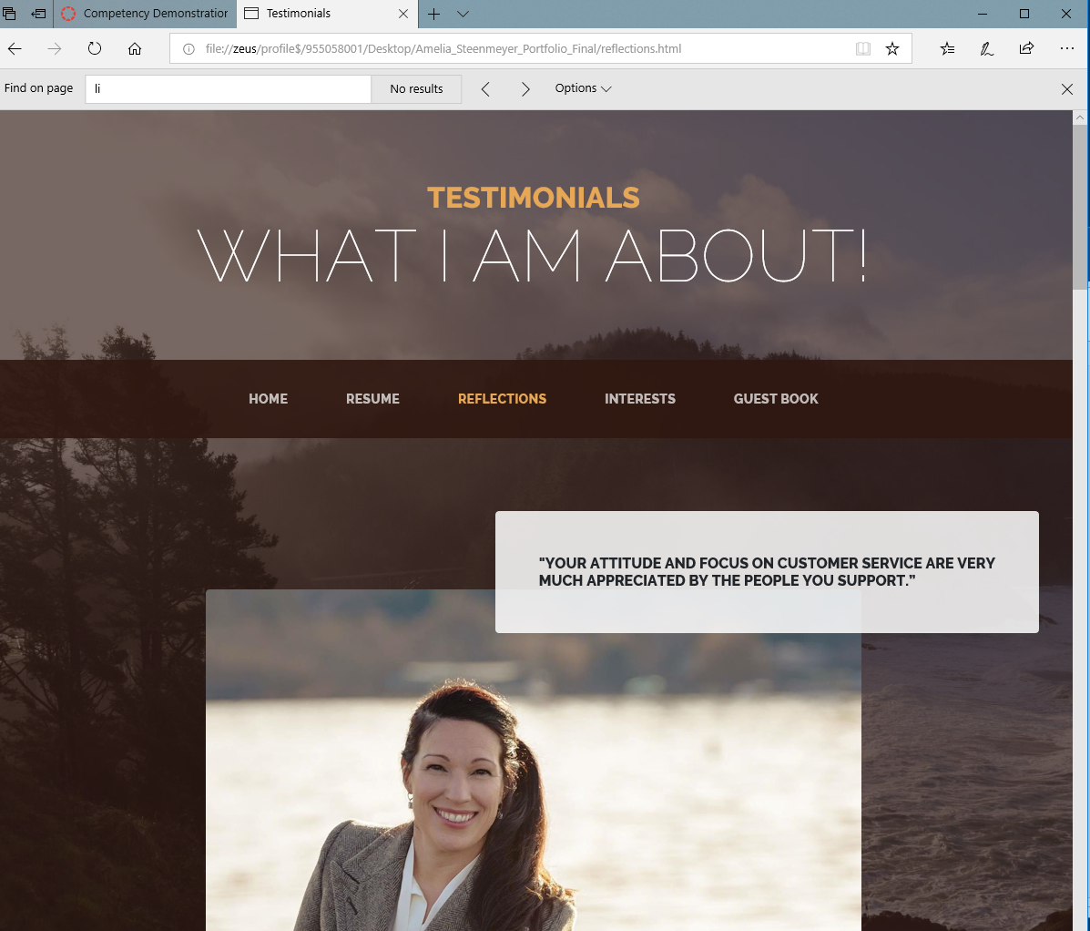

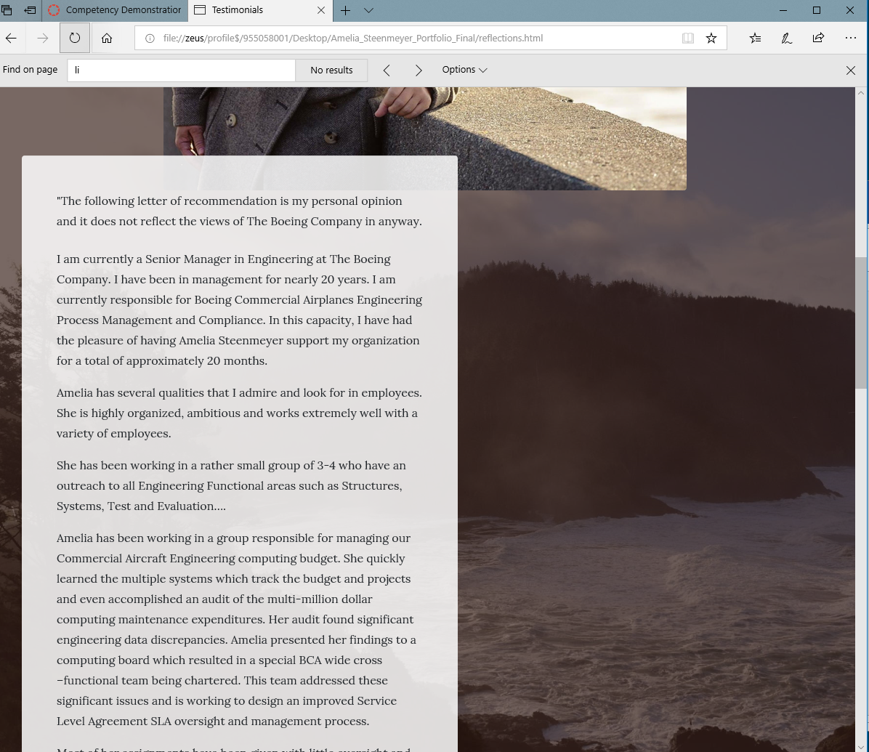

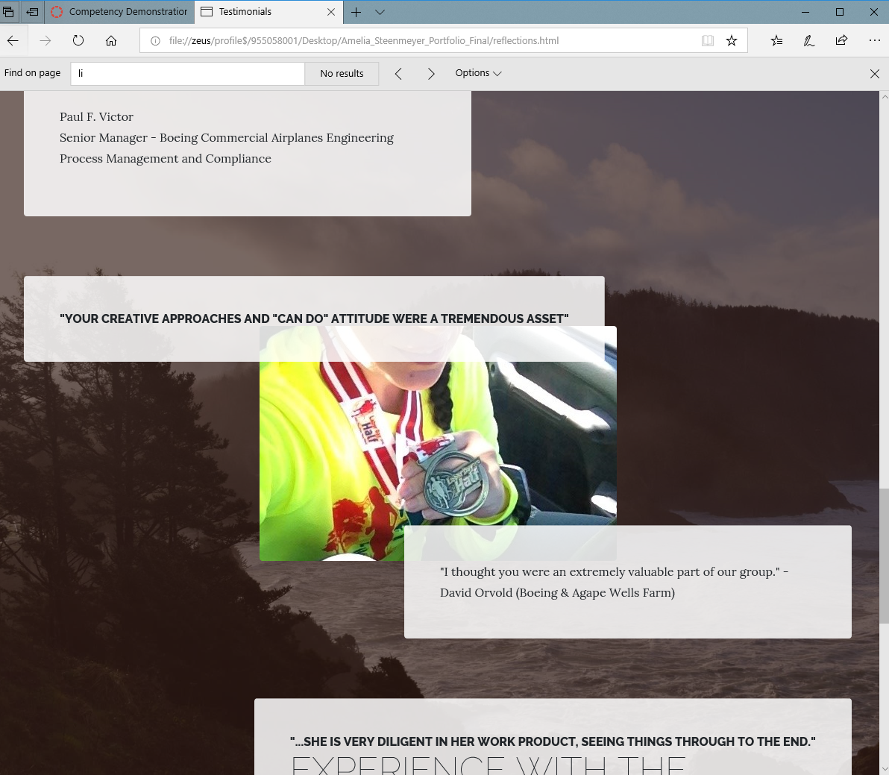

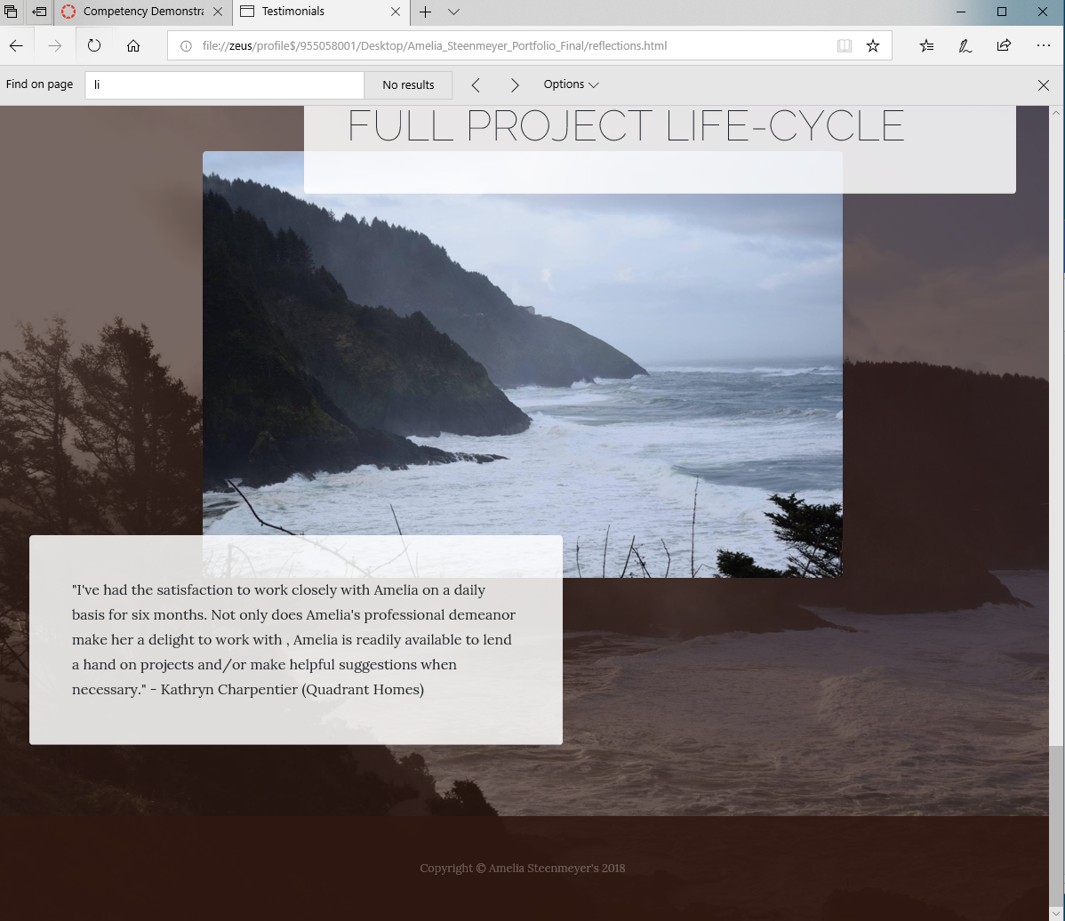

* You should strictly follow the naming convention for your files above.  If you do not you will lose points.
* Consistent navigation on all pages. This navigation should allow you to move from any one page within the site to another page within the site, without hitting a back or forward button on your browser
* You must include within your work a folder called documentation.

A site specification document, describing the features and purposes of the webpages in your project .You can see some Personal Web Site samples for Personal Web Site – Portfolio Project Description in our website http://cyberia.sandbox.edcc.edu

Submission:

1. Website: Loaded to GitHub______
2. Create screen captures of your web pages and paste it into a .docx, .doc, or .rtf and load to Canvas (Done 5pm on Dec3rd)
3. You also need to zip your website html and css files and upload here.  (A good free file archiver is available at <http://www.7-zip.org/download.html>

**Parking lot (The Next Steps)**

* Icon on tab
* Help from fellow student for site cleanup
* Complete Reflections and change to Portfolio (build with sample work)
* Another Language button on each page (Apply for visa to that country)
* ~~Guestbook.html (Nav Pane not highlighting correctly)~~